Electrical machines & Instruments

rmShoeb_CSE_16

**Machine**

A machine that converts mechanical energy into electrical energy and vice versa is called as an **Electrical Machine**. The machine that converts mechanical energy to electrical energy is called a **generator.** The machine that converts electrical energy to mechanical energy is called a **motor**. Transformers are also electrical machines because even though they don't convert one form of energy into another, they convert AC current from one voltage level to another.

Why electrical machines are so common?

1. Easy control
2. Flexibility
3. Transmission
4. Reliability
5. Safety
6. Cheapness
7. Cleanliness
8. No need of constant ventilation

DC Machines

**DC Generator**

It is an electric machine which converts mechanical energy to electrical energy.

**Faraday’s Law of electromagnetic induction**

It states that if a flux passes through a turns of coil, a voltage will be induced in that coil which is directly proportional to the rate of change in the flux with respect to time.

$$e∝\frac{dφ}{dt} e→induced e.m.f. φ→flux$$

**Lenz’s law**

It states that, the direction of the voltage build-up in the coil such that if the coil ends were short circuited, it would produce current that would cause a flux opposing the original flux change, since the induced voltage opposes the change that causes it. Hence, a minus sign is induced in the Faraday’s law and the law becomes,

$$e∝-\frac{dφ}{dt}$$

**Generator Action**

An electric generator is based on the principle of whenever a flux is cut by a conductor and emf is induced which will cause a current to flow to the conductor circuit is closed.

Three mandatory terms:

1. Conductor/group of conductors
2. Flux/magnetic flux
3. Motion of conductor with respect to field

Types of DC Generator

1. Self-excited
2. Series generator
3. Shunt generator
4. Compound generator
5. Short shunt
6. Long shunt

Again,

1. Differential
2. Cumulative

* Over
* Under
* Flat

1. Separately excited

**Self-excited DC Generator**

If the field winding is excited with its own armature winding other that any external DC exciter, is called self-exciter DC Generator.

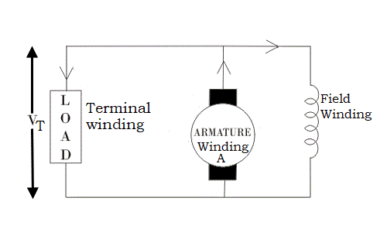

Fig.: Self-excited DC Generator

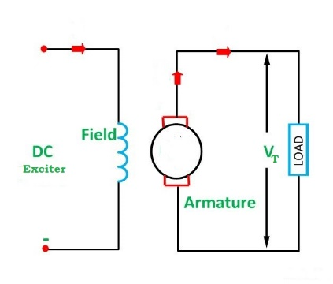

Fig.: Separately excited DC Generator

AC Machines

Synchronous Machines and Motors

Measuring Instruments

Transducers

[Resources:

1. ]